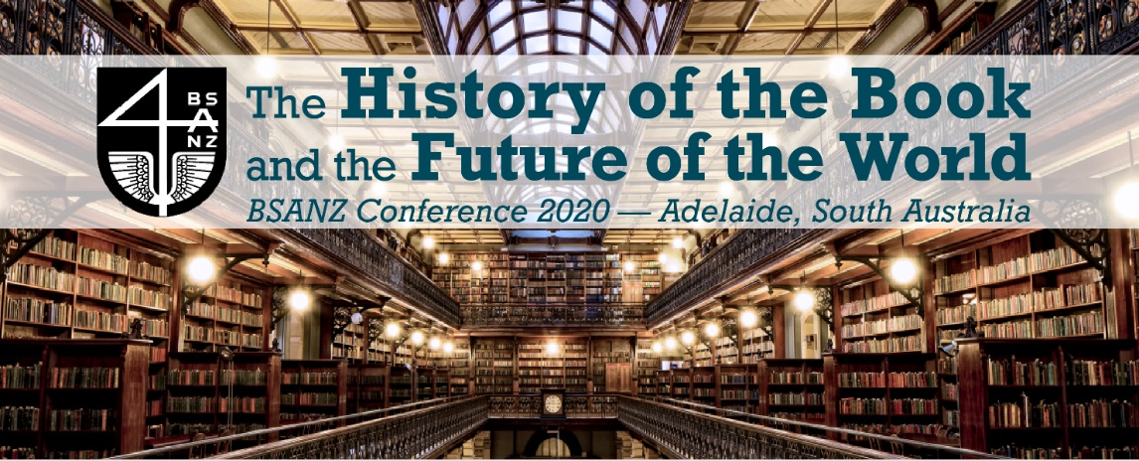
The Bibliographical Society of Australia and New Zealand (BSANZ) is pleased to announce the 2020 conference with the theme The History of the Book and the Future of the World, to be hosted at the State Library of South Australia Monday 30 November and Tuesday 1 December. There will be a Rare Book Librarians Day event on Wednesday 2 December.
Conference website https://sites.google.com/view/bsanz-conference-2020/home
This year’s conference theme seeks to acknowledge chaos in the world in many different domains and asks: what role can the study of the book, of physical and textual bibliography and the history of the written word play in cohering research and knowledge in service of solutions to some of the world’s wicked problems? What work can our research do to be of use in difficult times?
The theme of the conference is deliberately broad in scope. It hopes to illustrate the various ways in which bibliographical engagement with the textual artefacts of the past can offer social, environmental and political lessons for the future.
The following list is not intended to be exhaustive, and we welcome papers on all other topics that conform with the interests of the BSANZ. Some possible broad topics include:
- Reimagining ‘the book’ – material carriers of cultural knowledge and memory in oral cultures;
- The role of the printed word in preserving and renewing oral languages and cultures;
- The past and future sustainability of individual books, the book industries and the study of the book given climate catastrophe and sustainability agendas;
- Early encounters with print in Australia and New Zealand and elsewhere;
- Books and ‘the book’ as instruments, tools, or weapons of colonial power and its undoing;
- Implicit cultural bias in bibliographic schema and library catalogues;
- Inclusive approaches to bibliographic and book history studies;
- Published translations of western texts into Indigenous languages and vice versa;
- The role of book studies in the social good, including decolonising work, climate activism and other significant challenges we face on a local and global scale;
- Books as instruments of hope;
- The relationship between book history and critical race and whiteness studies;
- New ways of understanding book history, bibliography and the future of the book;
- Book ownership and collecting in the digital age.
Expressions of interest should be sent to the chair of the organising committee, Dr Gillian Dooley: gillian.dooley@flinders.edu.au by Tuesday 30 June 2020. Notifications of acceptance will be sent out by 31 July 2020.
Please note this conference aligns with Dark Enlightenments: the XVII David Nichol Smith Seminar in Eighteenth-Century Studies in Adelaide 2-4 December 2020 (CFP deadline 1 March) https://dnsxvii2020.wordpress.com/.
All conference presenters must be members of the BSANZ. http://www.bsanz.org/membership/

